**Changes that need to be made on the Department of Economics’ Website**

1. **Please change the one word highlighted on the front page info infront of the pics. Its written as “FOR” please make it for(like below)**

**Our Research Centres**

Department of Economics at the Lahore School of Economics has three Research Centers, Centre for Research in Economics & Business (CREB), Graduate Institute of Development Studies (GIDS) and Technology Management & Innovation Centre (TMIC). Its members include some of the country’s most distinguished academic economists whose research has made major contributions to modern economic analysis. CREB annually hosts International conference on the Management of Pakistan’s Economy attended by leading International and Pakistani Economists. The Department of Economics also issues biannual Journal, Lahore Journal of Economics (LJE), which have consistently received the highest rating by the Higher Education Commission of Pakistan (for the last seven years).

**_______________________________________________________________________________________**

1. Please change the following text which has been highlighted in yellow:

Latest News (website **outlook Front Page)**

**PhD students of LSE visit Oxford University, UK**

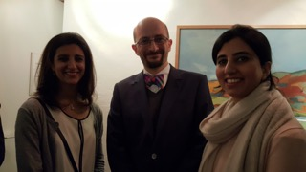

15/01/2016

Ms. Rabia Ikram, Assistant Professor,

and Ms. Farah Said, Assistant Professor & Research Fellow at Lahore School of Economics

visited Oxford University, UK in January,2016 under the PhD. Economics Students’ Exchange Program with the University of Oxford, UK

_________________________________________________________________________________________________

**External Events:**

1. **Please change the following 1st info given on the External Events page to the one highlighted (given below):**

|  |  |
| --- | --- |
| [**Conferences Attended by the Department of Economics**](http://admissions.lahoreschool.edu.pk/economics/con_att_deptecon.php)  **Researcher from CREB, Lahore School of Economics, represents South and East Asia in the conference on Advances with Field Experiment at University of Chicago, Illinois, USA** [**read more...**](http://admissions.lahoreschool.edu.pk/economics/con_att_deptecon.php) | **http://admissions.lahoreschool.edu.pk/economics/images/extevent6.png** |
|  |

|  |  |
| --- | --- |
| **Researcher from CREB, Lahore School of Economics, represents South**  **and East Asia in the conference on Advances with Field**  **Experiment at University of Chicago, Illinois, USA**  **Ms. Farah Said, Assistant Professor & Research Fellow at CREB , Lahore School of Economics, with researchers from the University of South California ,Tufts, University of Pennsylvania , Harvard, Yale , Columbia ,UC Berkley, London School of Economics, NYU, etc.**  [**read more...**](http://admissions.lahoreschool.edu.pk/economics/con_att_deptecon.php) | **http://admissions.lahoreschool.edu.pk/economics/images/extevent6.png** |
|  |

___________________________________________________________________________________________________________________

1. Faculty Profiles. Please replace all Qualifications headings with Degrees: and m,ake the following changes on individual profiles as given below:
2. **Anam Ahraf**

Please remove office and let the heading be **Latest working papers:**

**Office :**Latest Working Papers:

1. **Aqsa Amjad**

Please remove Tel and let the heading to be **Office:**

**Tel :**H2-14

1. **Ayesha Afzal**

Please remove Ext

**Tel :**+92-42-36560936 Ext.

1. **Farah Said**

**Please make following changes in her qualifications, they should appear like this:**

Degrees:

Ph.D. Candidate, Economics, Lahore School of Economics,

Pakistan, August 2013 -May 2018

Advisor: Azam Chaudhry

MSc., Financial Economics, University of Oxford, Oxford, UK, 2009

BSc. (hons.) Economics (Minor in Accounting and Finance),

Lahore University of Management Sciences, Lahore, Pakistan, 2008

Passed CFA level III in Aug 2014.

1. **Maha Khan**

**Degrees:**

M.Phil. Economics, Lahore School of Economics

B.Sc. (Hons.) Economics & Finance, Lahore School of Economics

**Recent News:**

Admission in PhD program in Economics at the University of York, UK and recipient of:

* Departmental Studentship
* Scholarship of Overseas Students covering tuition fee and living expenses during the doctoral program

**Conferences Attended:**

* International Curricular Forum organized by International Economic Association (IEA), in collaboration with Centre of Economic Research in Pakistan (CERP), Institute of Development and Economic Alternatives (IDEAS) and Lahore University of Management Sciences (LUMS), 17th - 19th December 2015.
* Informational meeting by RISE: Research on Improving Systems of Education, a DFID- funded program led by RISE research director Lant Pritchett, 3rd August 2015.
* The Lahore School of Economics and University of Oxford Conference on "Microfinance and Enterprise Development - Research Prospects and Challenges", April 2015.

F) **Mahnoor Asif**

**Degrees:**M.Phil. in Economics, Lahore School of Economics (Gold Medal)

B.Sc. (Hons.) Economics and Finance, Lahore School of Economics (Silver Medal

**G) Marjan Nasir**

**Degrees:**M.Phil. Economics, Lahore School of Economics

MBA Banking and Finance, Lahore School of Economics

B.Sc. (Hons.) Economics and Finance, Lahore School of Economics

**h) Maryiam Haroon**

**Degrees:**Candidate for Ph.D. Economics, Lahore School of Economics, Pakistan

M.Phil. in Economics, Lahore School of Economics, Pakistan

**Conferences Attended:**

* Paper presented at Lahore School of Economics Conference 2015:

The Economic Impact of New Firms in Punjab, Lahore Journal of Economics, 2, 143-182, Azam Chaudhry & Maryiam Haroon. (2015).

* Paper presented at 30th AGM meeting and PIDE Conference 2014

Growth in Pakistan: Inclusive or not? The Pakistan Development Review, Zunia Saif and Maryiam Haroon. (2015).

* Paper presented at Lahore School of Economics Conference 2012

The Birth of Exporters: Entry and Scale of Firms in Punjab's Export Sectors. The Lahore Journal of Economics, 17, 191-212, Azam Chaudhry, Marjan Nasir & Maryiam Haroon. (2012).

**Latest Working Paper:**

"Where do new firms locate? The effects of agglomeration on the formation and scale of operations of new firms in Punjab," Economics Discussion Papers 2014-21, Kiel Institute for the World Economy. Working paper series, Maryiam Haroon & Azam Chaudhry. (2014).

1. **Rabia Arif**

Degrees: Candidate for PhD. in Economics, Lahore School of Economics, Pakistan

M.Phil. Economics, Lahore School of Economics, Pakistan

B.Sc. (hons.) Economics, University of Lahore (External Program)

j) Rashid Amjad Chaudhry

**Degrees :**  
PhD. & B.A (Hons)., University of Cambridge, UK

Bachelors in Economics and Political Science, Government College, Lahore, Pakistan

**k) Sadia Imran**

**Degrees:** Master of Philosophy (M.Phil.) in Environmental Sciences, Lahore School of Economics, Pakistan, 2013  
Masters in Environmental Sciences, Kinnaird College for Women, Lahore, Pakistan, 2005  
Bachelor of Arts (B.A.) in Economics and Statistics, Kinnaird College for Women, Lahore, Pakistan, 2003

l) **Shamyla Chaudhry (please remove r from Chaudhry)**

**Degrees:** Enrolled in MSC in Industrial Relations and Workplace Learning, Leicester University, UK, 2015-to date

MSC in Economics, Finance and Management, Lahore School of Economics, Pakistan, 1996

**j) Uzma Afzal**

**Degrees:**MPhil in Economics, Lahore School of Economics, Pakistan

BSc (Hons) in Economics, Lahore University of Management and Sciences (LUMS), Pakistan

**k) Waqar Ahmed Wadho**

Degrees:   
Ph.D in Economics, GREQAM, Aix-Marseille School of Economics, Aix-Marseille University, France (2011)  
MS in Economic Analysis and Econometrics with specialization in Economic Theory, GREQAM, Aix-Marseille School of Economics, Aix-Marseille University, France (2007)

M.Sc Economics, Quaid I Azam University, Islamabad, Pakistan (2004)

l) **Zunia Saif Tirmazee**

**Degrees:**Candidate for Ph.D. in Economics, Lahore School of Economics, Pakistan-to date

Visiting Scholar, Oxford University-Lahore School Program, 2015

M.Phil. in Economics, Lahore School of Economics, Pakistan (2014)

B.Sc. (Hons.) in Economics and Finance, Lahore School of Economics, Pakistan (2010)

**Researchers:**

1. **Amna Zaidi**

**Degrees:**M.Sc. in Development Studies, Lahore School of Economics, Pakistan

BBA Hons, Finance & Environmental Policy, Lahore School of Economics, Pakistan

1. **Anum Ellahi**

**Degrees:** M.Phil in Finance, Lahore School of Economics, Pakistan

B.Sc. (Hons.) in Economics and Finance, Lahore School of Economics, Pakistan

1. **Anam Tariq Bukhari**

**Degrees :** M.Phil. in Economics, Lahore School of Economics, Pakistan

B.Sc. (Hons.) Development Economic, University of London, UK

1. **Javed Sadiq Malik**

**Degrees:**Masters, Fletchers School, Tufts University, USA

M.Sc. in Management, Arthur D. Little School of Management, Cambridge, Massachusetts, USA

1. Saman Zahra Khan

**Papers Written:**

* Profitability, Risk & Return Characteristics of Pairs Trading Strategy (MSc. Dissertation), Queen Mary University, UK (Oct 2015)
* How do changes in monetary policy and other macroeconomic variables affect stock prices? Queen Mary University, UK (April, 2015)
* How do changes in the (short-term) interest rate affect stock prices? Queen Mary University, UK (December, 2014)

1. [**Syeda Naimul Fatima**](http://admissions.lahoreschool.edu.pk/economics/syedanaimul.php) (Please remove her name)

______________________________________________________________________________________________________________

1. **Increase website size and heading and pics size ( overall outlook)**

**______________________________________________________________________________________________________________________**

1. **Please include one heading under Research Section as a separate Hrading“Economics Department Major Projects” as highlighted below:**

** Department of Economics**

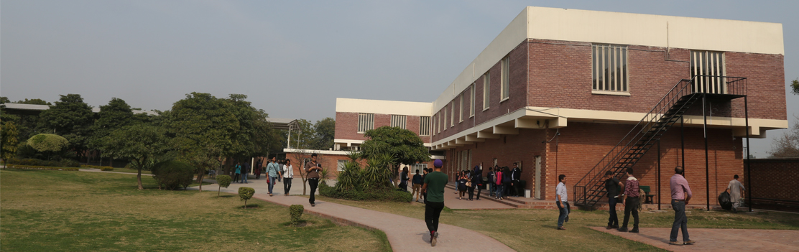

**Home People Research Prospective Students Events News & Media Contacts Us**

Faculty Centers  Undergraduate Programs Forthcoming Seminars News

 Researchers CREB Post-Graduate Programs External Events Media

 Graduate Students GIDS Economics Department Collaborations

 Technology Management & Innovation Centre  Past Events

Working Papers Annual Conference 2016

 CREB Working Papers  Annual Conference 2015

 Publications  Annual Conference 2014

 Lahore Journal of Economics (LJE)

 Economics Department Recent Publications

 Major Economics Department Projects

**QUICK LINKS PROSPECTIVE STUDENTS Useful Links STAY CONNECTED**

* [About Us](http://www.economics.ox.ac.uk/About-Us/about-us) Undergraduate *Programs*  Lahore School of Economics Facebook
* [Contact Us](http://www.economics.ox.ac.uk/index.php?option=com_contact&Itemid=230&id=53&lang=en&view=contacts) *Post-Graduate Programs* CREB LinkedIn
* [Degree](http://www.economics.ox.ac.uk/About-Us/finding-us) Programs GIDS Twitter

______________________________________________________________________________________________________________________

1. **Please include the following write up under “Major Economics Department Projects” which comes under Research:**

**Economics Department Major Research Projects**

**Incentivizing Attendance in Production Teams Dr. Theresa Chaudhry and Zunia Tirmazee**

The research team tested whether short-term financial incentives can be used to decrease worker absenteeism in one of Gujrat’s leading fan factories. In 2012 -2013, they piloted attendance incentive schemes on a sample of production teams. Comparing the attendance records of the teams offered the group-based incentive to a control group, the research team has found that the group-based incentive bonus increased the number of days that an announced attendance target was met.

The project was funded by the IGC and collaborators included Christopher Woodruff (University of Warwick) and Muhammad Haseeb (University of Warwick).

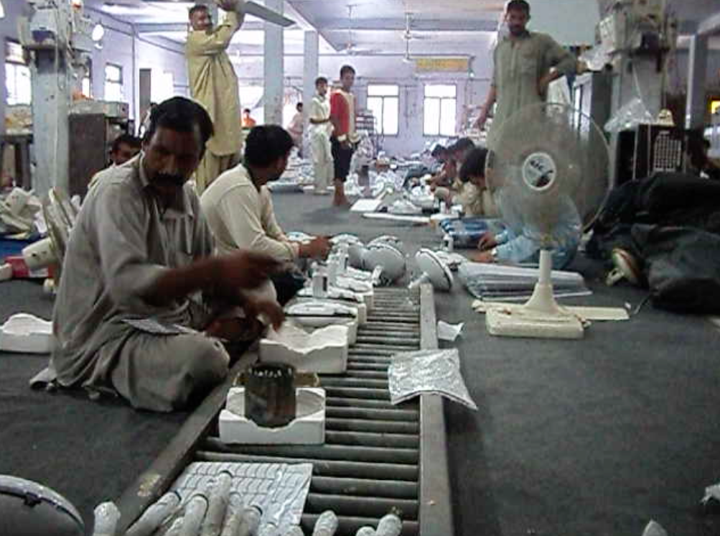

**______________________________________________________________________________**

**Causes and Consequences of Consanguineous Marriage in Pakistan Dr. Theresa Chaudhry**

The researchers examined the causes of consanguineous marriage, and attempted to measure the effects of consanguineous marriage, both negative and positive. In this project, nine (out of Punjab’s 35 districts) were randomly selected, comprising 70 sampling clusters. Interviews of just over 1000 households were conducted in October 2009.  A total of 4643 pregnancies were reported by 391 first cousin (37.6% of the marriages) and 622 non consanguineous couples interviewed in the study.

Collaborators include Mushfiq Mobarak (Yale University).

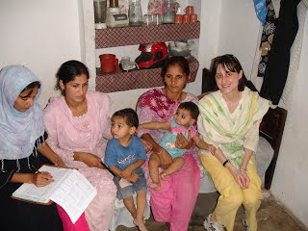

**____________________________________________________________________________________________________________**

**Conditional-Cash Transfers for Girls’ Secondary Schooling in Punjab: Outcomes Dr. Theresa Chaudhry**

The government of Punjab, starting in 2004, offered a conditional cash transfer (CCT) of Rs 200 per month, to girls in class 6 to 8 with minimum 80 percent attendance, in order to increase the educational attainment of girls in districts with less than 40 percent literacy.  Using data collected a survey of rural households in Punjab, the researchers analyzed the impacts of this CCT on enrollment and marriage outcomes by comparing eligible girls to their non-eligible elder sisters and younger siblings in both stipend and non-stipend districts.

This project was supported by the British Academy and Lahore School of Economics and collaborators include Mushfiq Mobarak (Yale University).

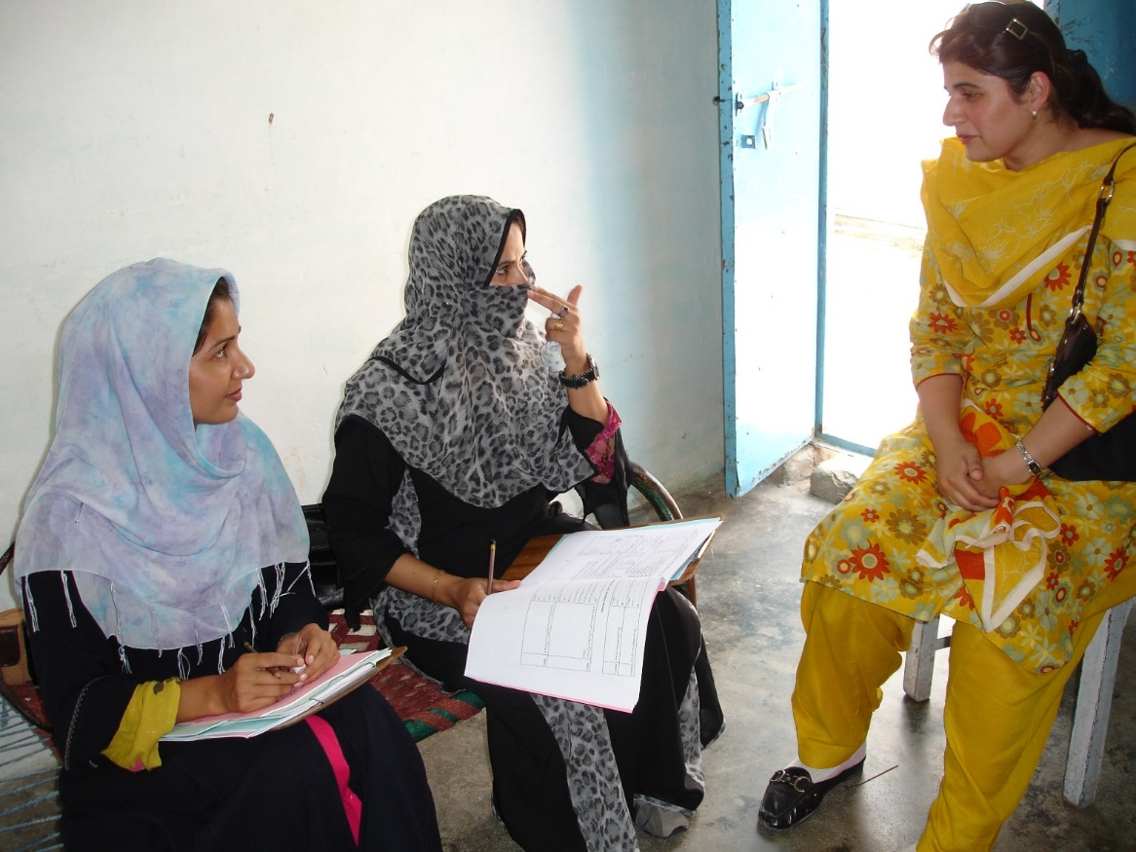

**____________________________________________________________________________________________________________**

**Rent-seeking, Government Size and Economic Growth Dr. Waqar Wadho and Umair Ayaz**

The research team is exploring the relationship between government size and economic growth in an endogenous growth model with human capital and unproductive social capital. The researchers show that with endogenous discounting, growth outcome is history dependent and is function of initial endowment of human capital. With low endowment, government intervention of any size is growth depressing. With high endowment, government intervention is not associated with any depressing effect. For intermediate levels, there are multiple equilibria. Furthermore, countries with identical endowment and government size can be in different equilibrium, and can have different growth rates within same equilibrium if they differ in institutional quality.

**___________________________________________________________________________________________________________**

**Two Sides of the Same Rupee? Comparing Demand for Microcredit and Microsaving in a Framed Field Experiment in Rural Pakistan Farah Said and Uzma Afzal**

The study is a Randomized Control Trial designed to compare the effectiveness of micro-savings and micro-loans as means for households to manage risk and liquidity.

This research is funded by the IGC and is collaboration between the Lahore School of Economics, the University of Oxford and the National Rural Support Programme (NRSP), Pakistan. Collaborators are Marcel Faffchamps (Stanford University), Giovanna d’Adda (University of Birmingham) and Simon Quinn (Oxford University).

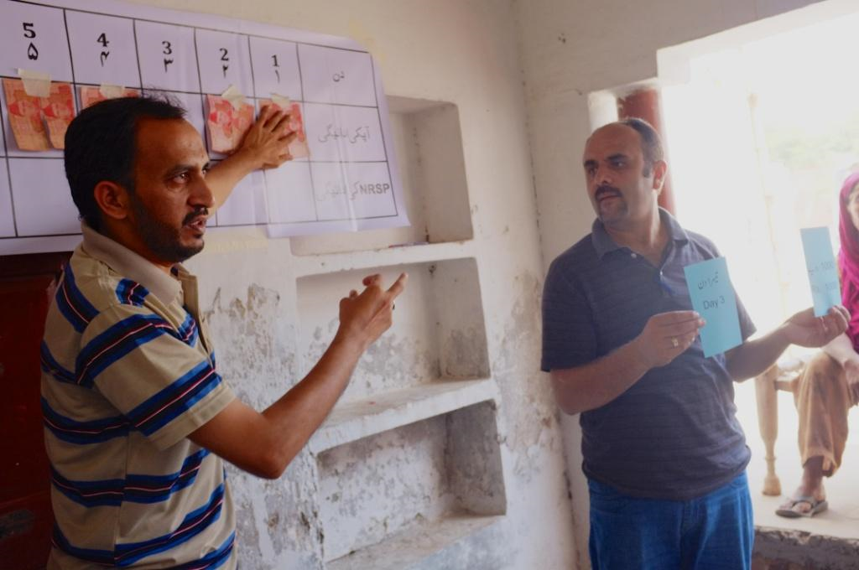

**____________________________________________________________________________________________________________**

**Impact assessment of startup loans to female run micro-enterprises Farah Said, Dr. Azam Chaudhry, Dr. Naved Hamid and Mahreen Mahmud.**

The study is an impact evaluation of a unique micro-loan product with a training component that is provided only to female borrowers to start-up their microenterprise.

Baseline activities were funded by the Kashf Foundation and were concluded in August 2014. Endline activities are being funded by the IGC.

This research is collaboration between researchers at the Lahore School of Economics, University of Kent, and the Kashf Foundation, Pakistan.

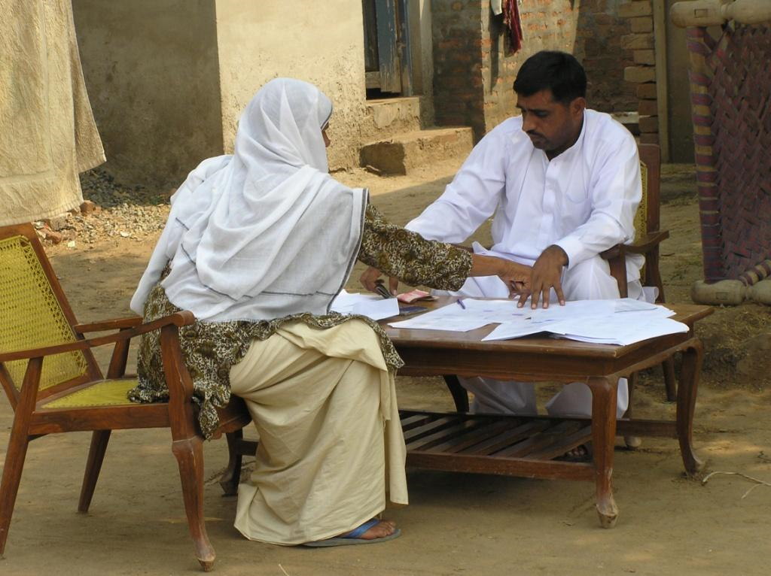

**____________________________________________________________________________________________________________**

**Pressures from peers and spouses and self-control problems as constraints to microenterprise growth: Experimental evidence from Pakistan Farah Said and Uzma Afzal**

This study is assessing the role of self-control problems and peer pressures on take-up and use of a financial product by female microentrepreneurs in Pakistan, by combining laboratory and field experiments.

This project is funded by the IGC and collaborators include Marcel Faffchamps (Stanford University) and Giovanna d’Adda (University of Birmingham).

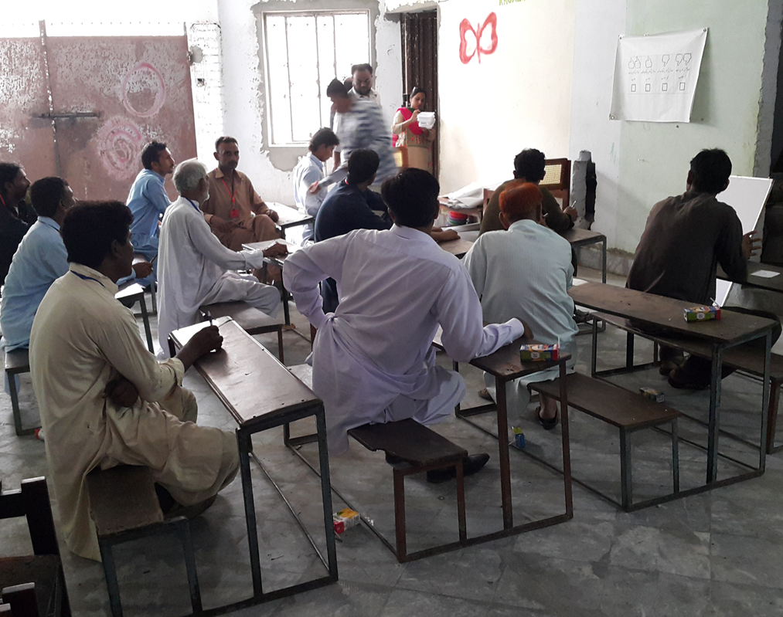

**____________________________________________________________________________________________________________**

**Learning about Disaster: Evidence from a field experiment in Pakistan Farah Said and Uzma Afzal**

This research project is using behavioral field experiments to study the effect of rare events on individual decision-making.

This research is being jointly funded by the British Academy International Partnerships grant and the Lahore School of Economics and is a collaboration between the Lahore School of Economics and the University of Oxford. Collaborators include Ginger Turner (University of Pennsylvania).

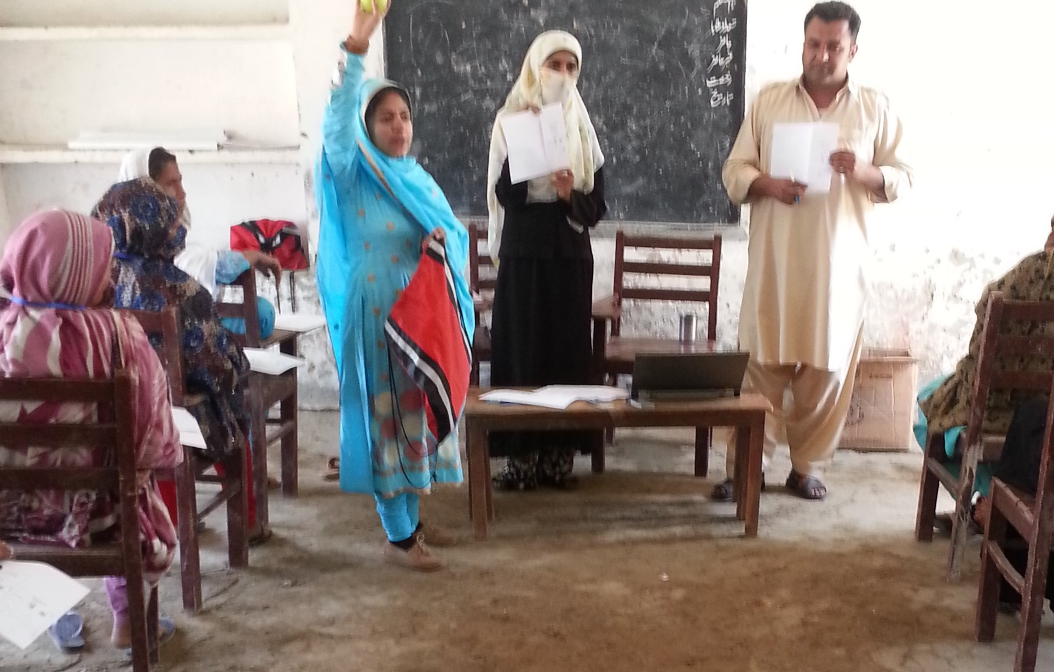

**____________________________________________________________________________________________________________**

**Incentivizing Development: A Field Experiment on Third Tier Organizations in Pakistan Hamna Ahmed and Asha Gul**

This study is a Randomized Control Trial (RCT) being funded by the Pakistan Poverty Alleviation Fund (PPAF). The study focuses on incentivizing development across 800 Local Support Organizations (LSOs) spread across Pakistan by testing the impact of two sustainable measures the donor can take to engage with these community-based organizations: (i) self-reporting and (ii) non-financial incentives.

Collaborators include Kate Vyborny (Duke University) and Simon Quinn (University of Oxford).

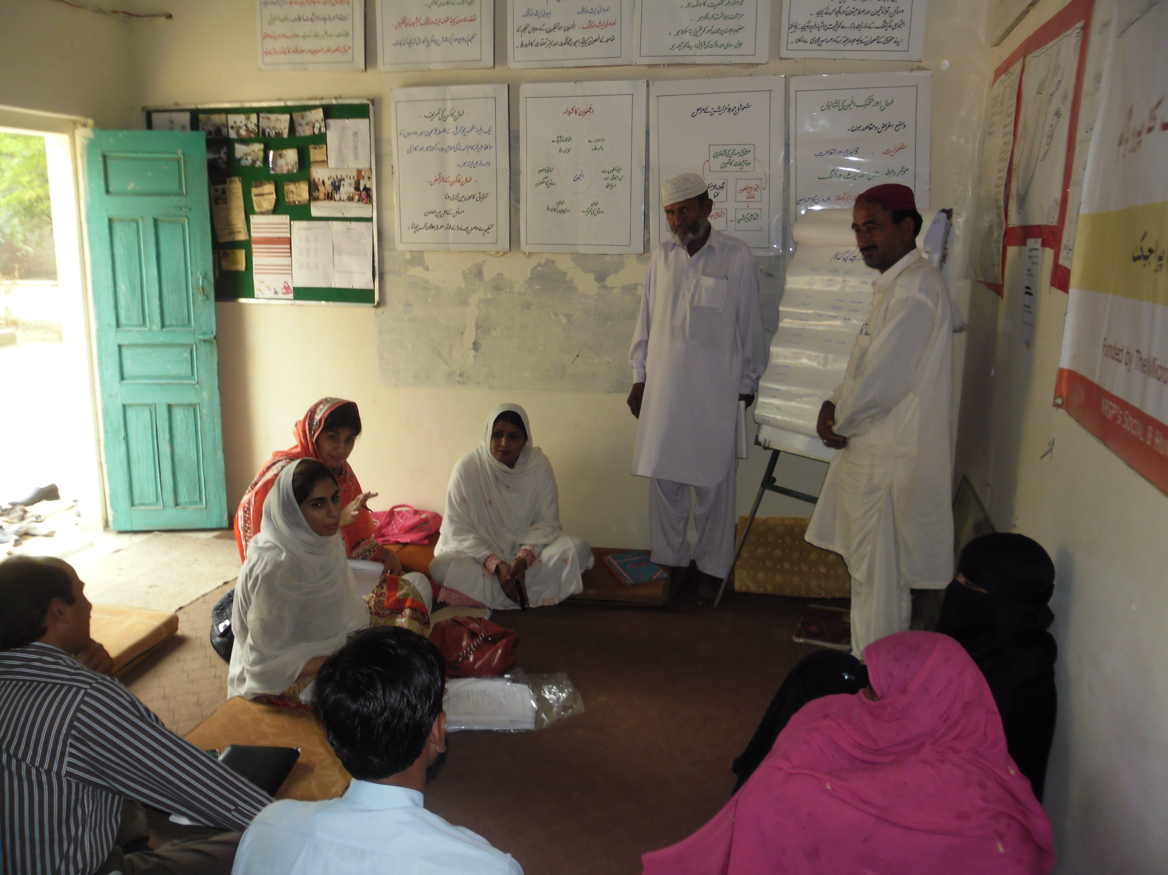

____________________________________________________________________________________________________________

**Technology Management & Innovation Website**

1. Change the highlighted headings

** Department of Economics**

**Technology Management & Innovation Centre**

|  |  |
| --- | --- |
|  | **Technology Management & Innovation Centre**  **Research Agenda**  **Major Research Projects** |

**Home People Major Research Projects Contacts Us**

**Team**

**Home:**

**The Centre for Technology Management & Innovation was established in April 2015 with an aim to promote innovation, a key to growth for Pakistan’s future. The Centre is headed by Dr. Azam Chaudhry, Dean and Professor, Faculty of Economics, Lahore School of Economics.**

**The objectives of the centre are:**

**• Work on firm level research on innovation and productivity.**

**• Conduct surveys with international researchers on innovation and technology.**

**• Collaborate with the government on Policy based research focusing on technological upgradation in the manufacturing sector.**

**• Work with the Lahore Chamber of Commerce and other industrial organizations to promote technological innovation in Pakistan.**

**________________________________________________________________________________________________________________________________________________________**

1. **( Text that would appear in front of the pics)**

**Welcome to the Technology Management & Innovation Centre**

The Technology Management & Innovation Centre (TMIC) at the Lahore School of Economics intends to provide a platform for academics, business, industry and the public sector to work in partnership and find solutions to challenges that matter in areas of economic importance including the manufacturing, exports, readymade garments and textiles.

**Research Agenda**

* Work on firm level research on innovation and productivity.
* Conduct surveys with international researchers on innovation and technology.
* Collaborate with the government on Policy based research focusing on technological upgradation in the manufacturing sector.
* Work with industrial organizations to promote technological innovation in Pakistan.

**Major Research Projects**

1. Analysis of Technology in the Sialkot Soccer Ball industry
2. Benchmarking of Productivity in Pakistan's Readymade Garment Sector
3. Technology and Innovation Mapping Project
4. Measuring Innovation in the Textiles Sector of Pakistan
5. Business Confidence Survey

**_________________________________________________________________________________**

**Technology Management & Innovation Website**

**Please increase the gaps between these headings so that that they are spread out:**

**Home People Major Research Projects Contacts Us**

**________________________________________________________________________________________________________________________________________________________**

**Remove the following picture on the innovation website and replace it with the Fan sector picture given below:**

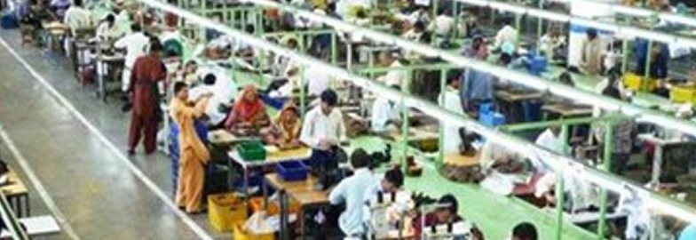

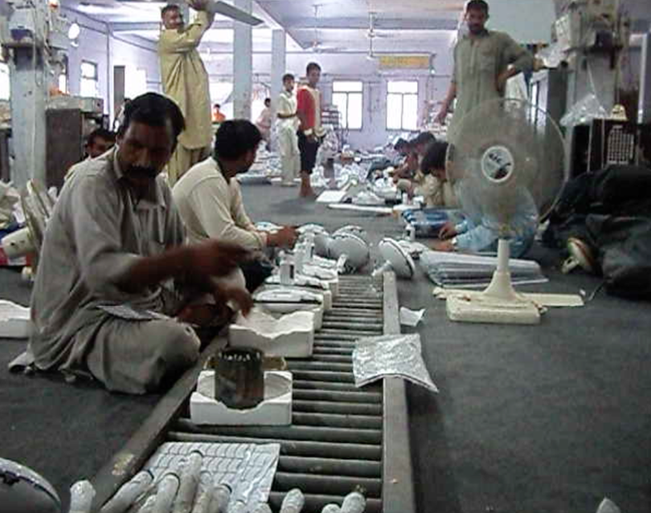

**________________________________________________________________________________________________________________________________________________________**

1. **Media ( Please list this new article in Media published recently:**



**Manufacturers of Pakistani Garments and Fans Struggle with Quality, Management, Worker Absenteeism and Entrenched Piece-Rate Wages**

Textiles account for over half of Pakistan’s exports, reaching US $ 3.72 billion in 2011/12. On the other hand, the electric fan sector in Pakistan has historically focused on production for the domestic market, but has diversified into export markets over the last 10-15 years, with exports reaching US$ 40 million in 2012.

Surveys conducted by researchers at the Lahore School of Economics in both these sectors identified problems that firms face in middle management, monitoring of quality, worker absenteeism, and wage practices. Academic studies carried out on firms in India and other countries have shown a profound and positive impact of sound management practices on firm-level performance. Firms in Pakistan are working to improve, but have a long way to go before they achieve international levels of management quality.

Ready-made garment (RMG) producers in Punjab are concentrated in and around Lahore. Garments are produced along an assembly line similarly to other producers around the world. On the other hand, fan manufacturers in Punjab are clustered in the Gujrat and Gujranwala districts. Fans are produced using a traditional batch system here, even though internationally, large producers such as China manufacture fans along an assembly line. In the batch system, production takes place in stages in individual workshops by teams of workers, under the supervision of a team leader known as an ustad.

In both sectors, much of the responsibility for the day-to-day management of production and quality is delegated to supervisors on the factory floor who have little or no formal training. These are the ustads and a few foremen in the fan sector and production and quality supervisors in the garment sector. Both sectors cite worker absenteeism as a major problem that they face as it creates bottlenecks in the production process.

In response to weak middle management (of maybe because of it), both sectors pay wages that are piece-rates; that is, the worker gets paid based on the number of units produced. This is not considered best practice in either sector for a variety of reasons. Insiders believe that piece-rates are responsible for quality issues and therefore both sectors hire a large number of quality inspectors. But managers face a quantity-quality trade-off: they do not think that they can get workers to complete export orders on time for foreign buyers unless they use piece-rates to incentivize the workers. Beyond the quality quantity tradeoff, piece rates may have other consequences, such as higher costs and hindering the adoption of new technologies.

Workers are also very comfortable with the piece-rate system and resist changes to it. For example, when one large fan manufacturer attempted to move from the outdated batch manufacturing process to an assembly line to reduce both costs and defects workers refused to adapt to the new system. One reason was it meant they would be shifted to salaries from piece-rates. The combination of piece-rates and batch production made it easier for workers to take breaks during the day or even take days off for family commitments, odd jobs or seasonal agricultural work in the villages.

Firms in both sectors believe that if more women entered the workface and took salaried jobs, the quality problems would be resolved. Under these circumstances, international buyers can also play a role in mandating changes in labor or wage practices as the firms in Pakistan have been responsive to buyers’ rules and regulations.

This IGC funded research study was conducted by Dr. Theresa Chaudhry, Professor, Lahore School of Economics and Ms. Mahvesh Faran, Lahore School of Economics.

**Link to the Article in the Express Tribune**

**______________________________________________________________________________________________________________________**

**Link to the Articles (Media Section): please add the following links arranged in order of their appearance on the website:**

1. Link to the Article in the Express Tribune
2. Link to the Article in the Express Tribune
3. Link to the Article in Daily Times
4. Link to the Article in Daily Times
5. Link to the Article in Daily Times
6. Link to the Article in the Express Tribune

Link to the Article in Daily Times

1. Link to the Article in the Express Tribune
2. Link to the Article in The News International

____________________________________________________________________________________________________________

1. **There are gaps in modules. Please correct the formatting of all modules in Undergraduate and Post-graduate Programs:**

**BSc (Hons) with Double Major in Economics and Management**

|  |  |  |  |
| --- | --- | --- | --- |
| **1st Year** | **2nd Year** | **3rd Year** | **4th Year** |
| Winter Term: Sept. - Dec | Winter Term: Sept. - Dec | Winter Term: Sept. - Dec | Winter Term: Sept. - Dec |
| 1. Intro to Micro Econ 2. Mathematics I 3. Statistics I 4. Computing for Business & Economics I 5. Communication Skills 6. Islamic Studies | 1. History of Economic Thought 2. Public Sector Economics 3. Financial Accounting I 4. Mathematical Economics 5. Principles of Marketing 6. Economic and Financial Analysis of Projects | 1. Micro Economics I 2. Macro Economics I 3. Financial Mgmt. II 4. Intro to Consumer Behavior 5. OB & HRM 6. Operations Management | 1. Time Series Analysis & Forecasting 2. Pakistan Economy 3. Research Methods 4. Monetary Economics 5. Financial Institutions & Markets 6. Marketing Management |
| Spring Term: Jan. - May | Spring Term: Jan. - May | Spring Term: Jan. - May | Spring Term: Jan. - May |
| 1. Intro to Macro Econ 2. Mathematics II 3. Statistics II 4. Computing for Business & Economics II 5. Academic Writing 6. Pakistan Studies | 1. Environmental and Natural Resource Economics 2. Financial Management I 3. Financial Accounting II 4. Principles of Management 5. Business Law 6. Development Economics | 1. Micro Economics II 2. Macro Economics II 3. Financial Statement Analysis 4. Advertising 5. Banking 6. Econometrics | 1. Entrepreneurship & SME Management 2. International Economics 3. Strategic Management 4. Supply Chain Management 5. Economic Growth 6. Research Project |

**Technology and Management Website:**

**Remove Department of Economics from the Technology Management & Innovation Centre Website**

** Department of Economics**

**Technology Management & Innovation Centre**

|  |  |
| --- | --- |
|  | **Technology Management & Innovation Centre**  **Research Agenda**  **Major Research Projects** |

**Home People Major Research Projects Contacts Us**

**_________________________________________________________________________________**

**Please add one heading “Business Confidence Surveys as highlighted below and attached two pdf files titled “Business Confidence Report 2015 & Business Confidence Report 2016”**



**Technology Management & Innovation Centre**

|  |  |
| --- | --- |
|  | **Technology Management & Innovation Centre**  **Research Agenda**  **Major Research Projects** |

**Home People Major Research Projects Business Confidence Surveys Contacts Us**

**___________________________________________________________________________________________________________**

* 1. **Text that would appear under the heading Business Confidence Surveys: Please give links to two pds reports Business Confidence Report titled “Business Confidence Report 2015 & Business Confidence Report 2016”**

**Business Confidence Surveys:**

In March 2015, the Lahore School of Economics and the Lahore Chamber of Commerce & Industry (LCCI) signed a Memorandum of Understanding which established a link between academia and the business community. As part of this collaboration, the Lahore School and the LCCI conducts annual business confidence survey to understand the perceptions of the business community regarding the prevailing economic conditions. Lahore School of Economics and LCCI has launched two “Business Confidence Reports” based on the surveys conducted in 2015 and 2016.

**Business Confidence Report 2016**

**Business Confidence Report 2015**

**____________________________________________________________________________________________________________**

* 1. **Please increase the gaps between the headings**

**Home People Major Research Projects Business Confidence Surveys Contacts Us**

**____________________________________________________________________________________________________________**

**Please add this on “Technology Management & Innovation Website”**

[Contact Us](http://admissions.lahoreschool.edu.pk/economics/contactus.php) | [Finding Us](http://admissions.lahoreschool.edu.pk/economics/findus.php) | [Student Portal](http://admissions.lahoreschool.edu.pk/student/)

Top of Form



**____________________________________________________________________________________________________________**